Project Design Phase-II
Technology Stack (Architecture & Stack)
Date | 25 September 2026
Team ID | SWTID-2026-3161
Project Name | Script-Controlled ACL – Restrict Record Access Based on Field Value
Maximum Marks | 4 Marks

Technical Architecture
The architecture below shows how a record access request flows through the Script-Controlled ACL system, from the user's request to the field-value evaluation, the access decision, and the audit trail an administrator can review.
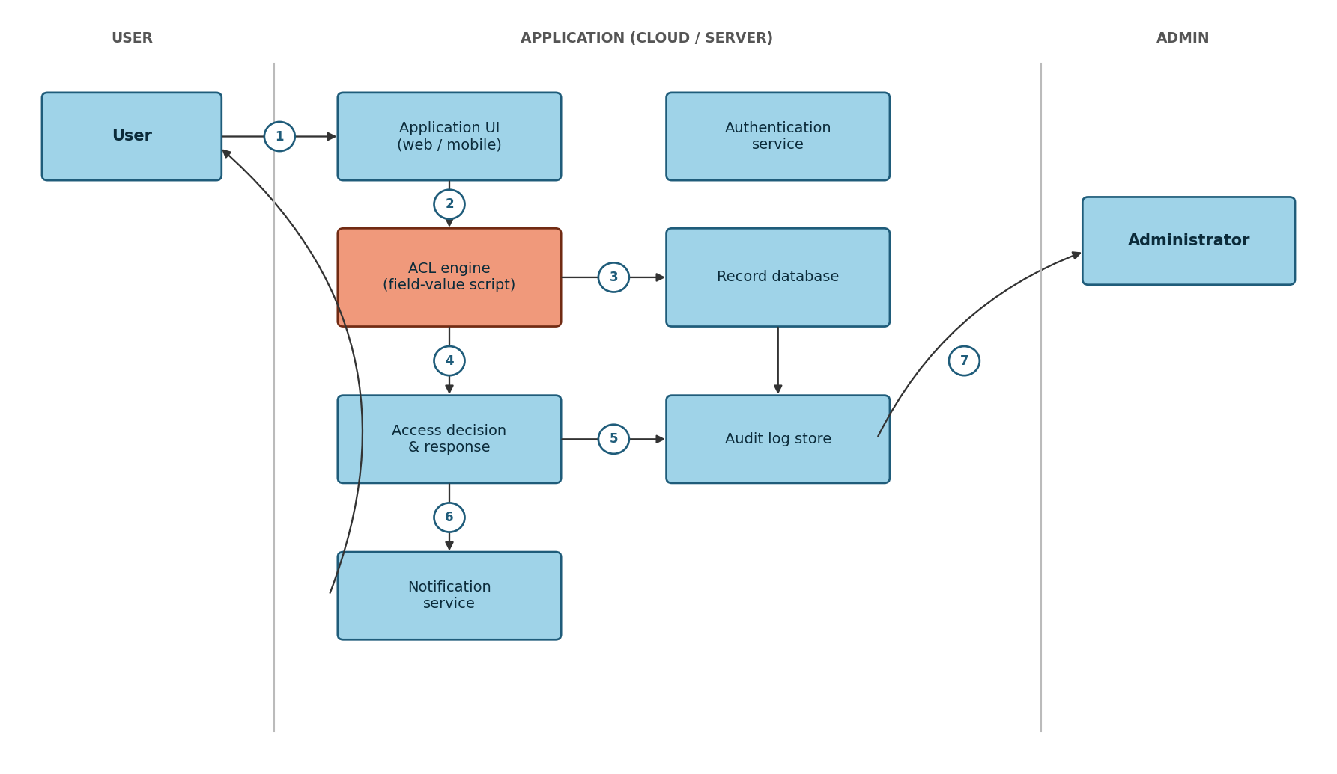

Table-1: Components & Technologies
S.No | Component | Description | Technology
1. | User interface | How the user requests record access | HTML, CSS, JavaScript / React JS
2. | Application logic-1 | Authentication & request routing | Node.js / Java / Python
3. | Application logic-2 | ACL engine – evaluates the field-value condition | Server-side script (Java / Python / JavaScript)
4. | Application logic-3 | Access decision & response handling | Node.js / Java / Python
5. | Database | Stores the records the ACL protects | MySQL / PostgreSQL
6. | Cloud database | Database service on cloud | AWS RDS / IBM DB2 / MongoDB Atlas
7. | File storage | Audit log storage | AWS S3 or local filesystem
8. | External API-1 | Identity / role lookup for the requesting user | OAuth2 / LDAP API
9. | External API-2 | Sends denial / alert notifications | SMTP / Twilio API
10. | Machine learning model | Not applicable to this feature | N/A
11. | Infrastructure (server / cloud) | Application deployment  Local Server Configuration:  Cloud Server Configuration: | Local, Cloud Foundry, Kubernetes, etc.

Table-2: Application Characteristics
S.No | Characteristics | Description | Technology
1. | Open-source frameworks | Frameworks used to build the ACL service and UI | Express.js / Spring Boot / Django
2. | Security implementations | Role check plus field-value ACL, encryption, and access controls | TLS/HTTPS, AES-256, IAM/OAuth2, OWASP practices
3. | Scalable architecture | Stateless ACL evaluation service that scales horizontally behind a load balancer | Microservice, container orchestration
4. | Availability | Multiple instances across zones with health checks and failover | Load balancer, multi-AZ deployment
5. | Performance | Caches frequently evaluated rules; logs audit entries asynchronously | In-memory cache, async queue

References
https://c4model.com/
https://www.ibm.com/cloud/architecture
https://aws.amazon.com/architecture
How to draw useful technical architecture diagrams

